**Administrator guide**

**jWebSocket**

**C# Client Library**

**Version 1.0**

Version Control

|  |  |  |  |
| --- | --- | --- | --- |
| **Date** | **Version** | **Description** | **Author** |
| 4/3/12 | 1.0 | Creation of the document | Rolando Betancourt Toucet |

1. **Process application download**

To achieve the correct operation of this library you need to download the following files.

|  |  |  |
| --- | --- | --- |
| **Archivo** | **Tamaño** | **Descripción** |
| ClientLibrary.dll | 52 KB | Main file that contains all the business logic. |
| log4net.dll | 292 KB | Is referenced by ClientLibrary.dll. |
| JSON.dll | 16 KB | Is referenced by ClientLibrary.dll. |
| Config.xml | 2 KB | Configuration file. |
| CSharpClientLibrary.rar | 121 KB | Contains all files. A .rar in the SVN is not appropriate! The SVN is supposed to maintain the source code in a compilable way! We need to change that! |

The URL where it is available for download is: *<https://jwsdev.org:9443/svn/jWebSocket/branches/jWebSocket-1.0/jWebSocketCSClient>*

In the SVN we do not maintain archives or binaries since, these are generated at deploytime or release time! Please check in the sources in their normal and standardized folder structure into the SVN!

All downloads should be zips not rars, since for rar the users need a special software, zips usually can easily be unzipped in all Operating systems!

Please describe which files need to be part of the downloadable zip and I will setup a deploy automation for this, which then can be check by you! Thanks.

1. **Characteristics of the installation environment**

You need to have an environment running Windows XP or any later version. Must have an installation of the Integrated Development Environment (IDE) Visual Studio 2005 or a later version and. NET Framework 4.0

How can I easily get this, please give download links for the required resources (like VS 2005 or the .NET Framework) for the convenience of the reader.

1. **Installation process**
2. Create a form application or console application using the Visual Studio IDE.

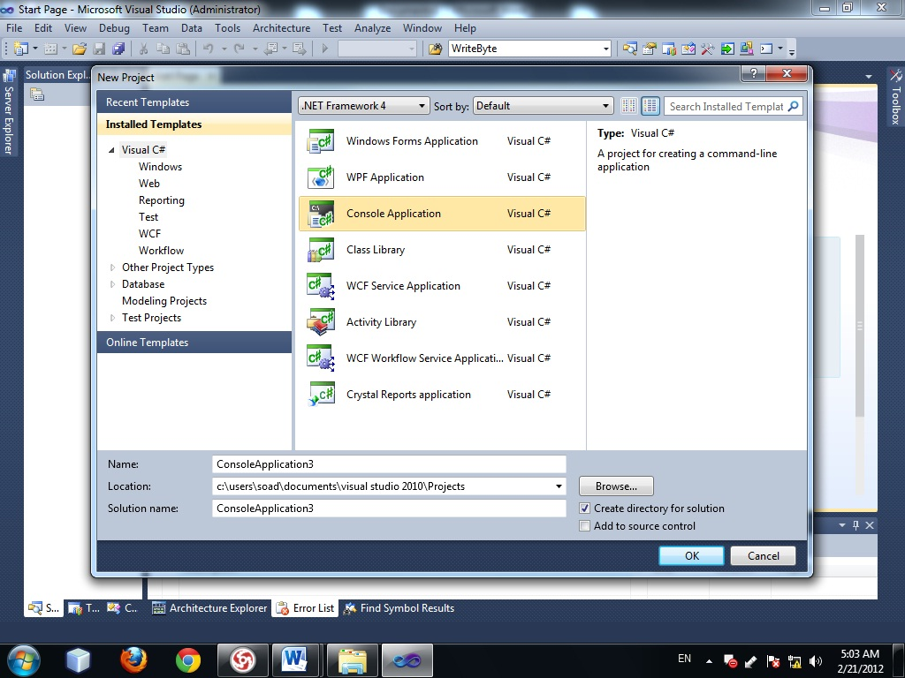

***Picture 1:****Create application*

1. Select the Framework 4.0 which is recommended to develop the application.

* Right-click the recently created project, where the menu will to mark the latter option “properties”.
* In the option Target Frameworks we choose .NET Framework 4.0.

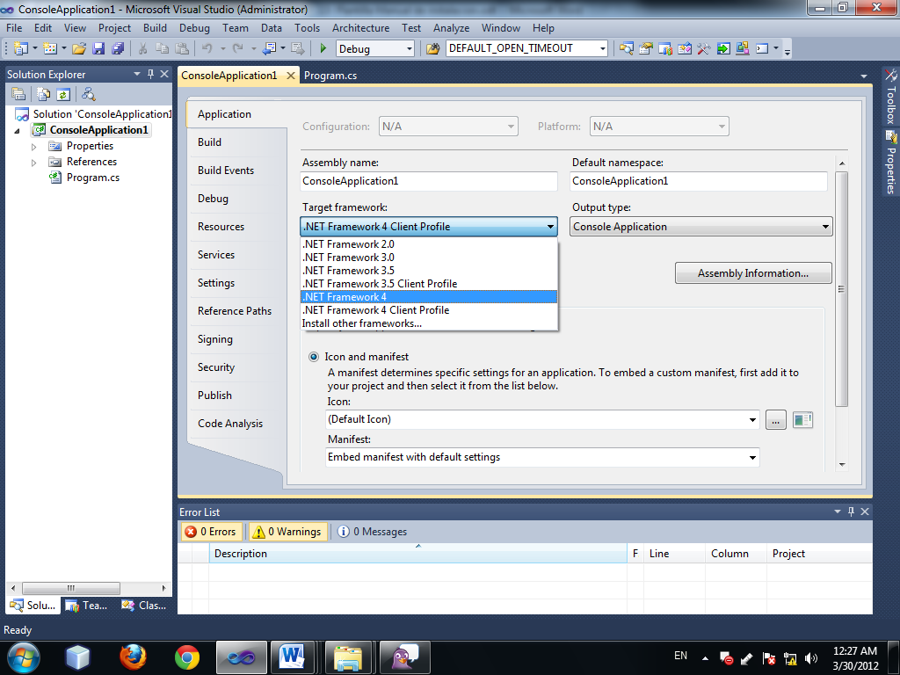

***Picture 2:****Select Framework*

1. Must copy the installation files in the root directory of your application to add reference.

* Right click on References and choose the option Add References.
* In the new window choose the tab Browse
* Look root directory and select the files you're going to reference

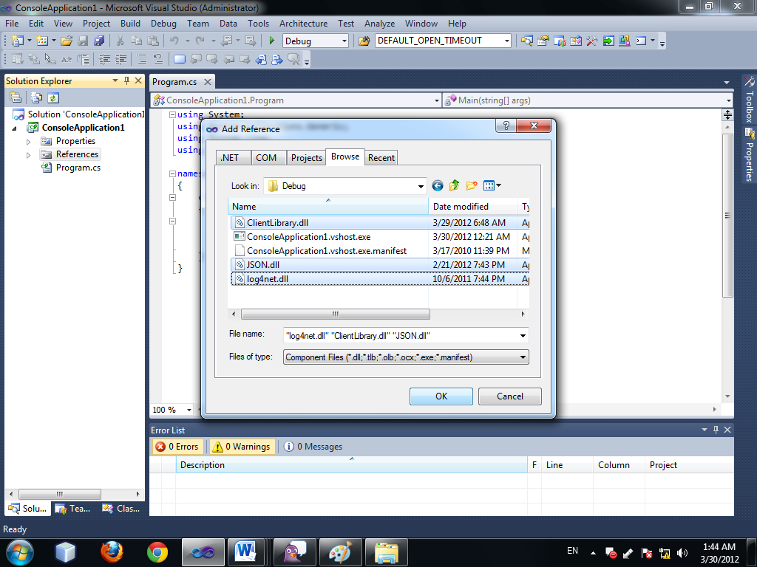

***Picture 3:****Add reference*

1. Add the namespace from 3 libraries in class where Let us go to use.

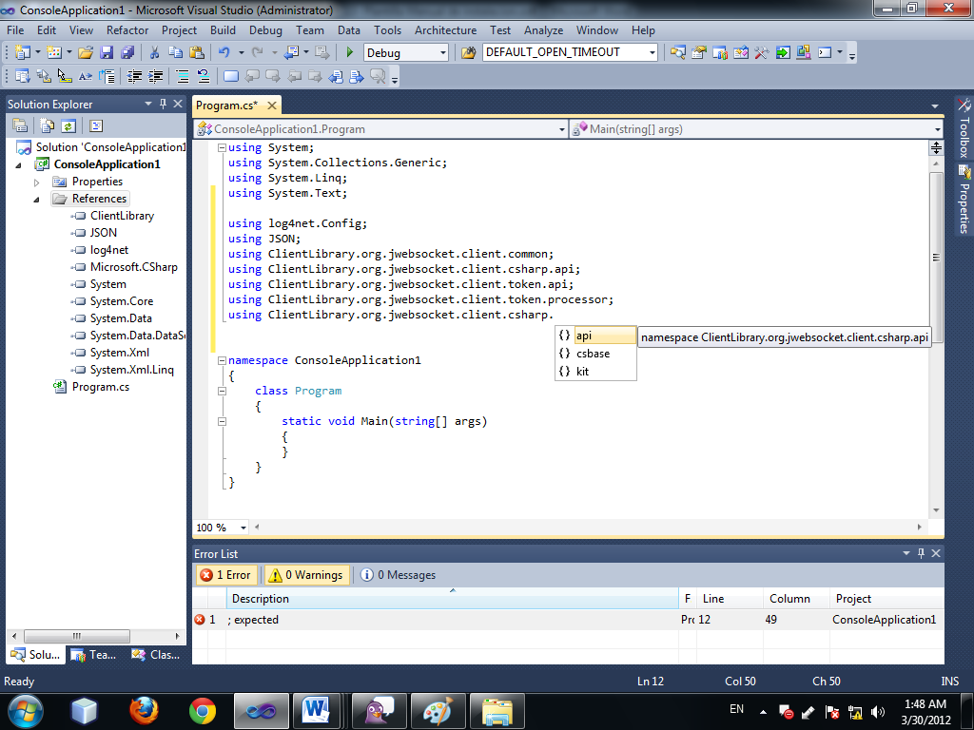

***Picture 1:****Add namesp**a**ce*

Ok, so far, only were do I get the source codes, in which folders do I have to unpack them, how can I check out from SVN?

This part needs to be overhauled! Please contact me in the chat to clarify questions and discuss suggestions.

**3.1 Hardware implementation (optional)**

No need to specify hardware features.

**4. Configuration Options**

Using the Config.xml file you can change some parameters of the operation of the application.

“Some parameters” ? Which parameters, which options or values per parameter? This is insufficient! Here we need more details! Also see my mail.

**5. Initial operation**

No need for post-installation configurations.

How and were is the URL configured? I remember I saw a UI, no? This is completely not mentioned here?

**5. Application Management**

No need to manage the application.

What about users, URL (ws/wss) ports etc. ?

I miss a lot of valuable information here!